Registration Article 9
(send by email in Word file to AWB; instantievoordierenwelzijn@radboudumc.nl)

General information regarding Access to the CDL: Animal experiment - Radboudumc
To be filled out by the researcher:
Personal information
Surname: | First name(s):
Title: | Other (optional):
Work E-mail: | Telephone number:
Employed since:
Department/faculty: | Room number:
Your supervisor:
Animal species involved in your experiments:
CDL team*:  *Ask your colleagues or coordinator animal experiments at which team your experiments are carried out. | Team 1 (TNU)  Team 2 (EBD/Tox and Isolators)  Team 3 (PRIME)
Personal number ( Z xxx or U xxx)
Education
Master degree branch of studies*: |  | Year:
Legal article 9 course: Yes / No* |  | Year:
Species-specific lab animal course: Yes / No* |  | Year:

Herewith requests registration as an article 9 employee according to the Animal Act.

* Please add copies of:
- the Master diploma,
- Article 9 certificate (LAS course)
- proof of complementary requirements (if applicable),
- exemption by the Inspection (if applicable).

To be filled out by the animal welfare officer:

Authorised by
Name:
Date:

To be filled out by the secretariat:

Confirmed and archived
Copy of diploma attached: Yes/No
Confirmation to the researcher: | Date: | Initials:
Added to data base article 9 employees: |  | Initials:
Appendix 1
The article 9 status provides the adequate training level to design projects and animal experiments. However, to carry out animal procedures, taking care or killing of animals you need to be (additionally) trained. Until you have demonstrated the required competency, you can only perform these tasks under supervision of a competent person. Also professional animal caretakers and animal technicians need to be assessed with respect to their practical skills. The Radboud University policy on competency can be found on the CDL-website: It's all about competency - Radboudumc.

Training Record

This provides a suitable format for in house training.

Name of trainee: ………….

Procedure | Training dates | Trained by | Level of training  (1-5) | Remarks (ready for assessment?)

Explanation of the training levels 1-5 is given in the scheme below. To be allowed to work independently at level 2, 1 or 0, there must first be an assessment of skills at that level.

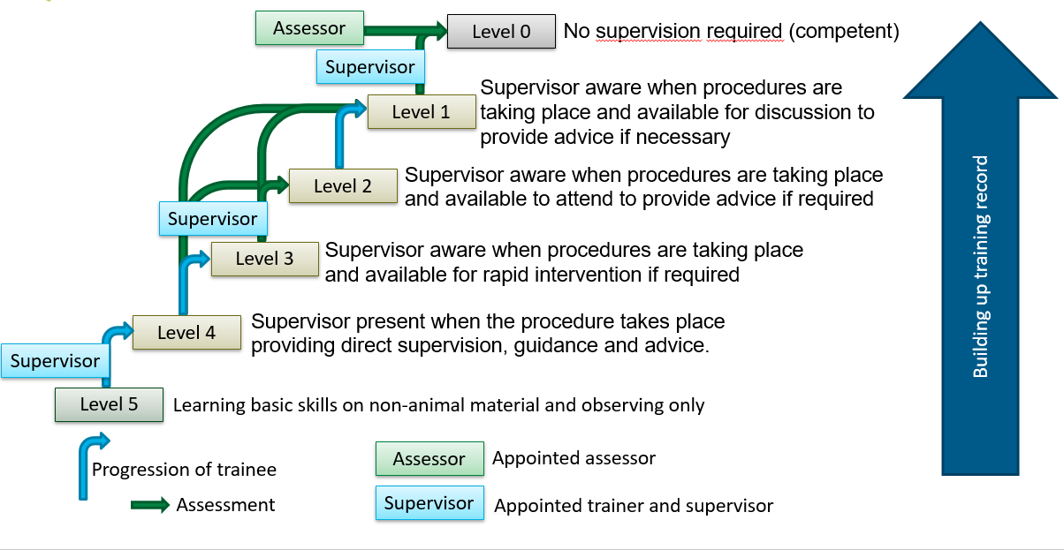

Assessment Criteria

In general you need to be trained (and records of this training need to be kept) for each procedure, and your practical skills will be assessed before unsupervised execution of the procedure is allowed. The Assessment Criteria are summarized in the following ‘generic assessment checklist’. Guided by these points, a person’s competence is determined.

- Making proper preparations,
- Performing the procedures correctly,
- Understanding of the technique (theory behind it) and means used (including injection fluids).
- An eye for animal welfare (3 Rs), including aftercare, and acting accordingly,
- Ability to self-reflect on the manner of execution

In summary you need to be trained (and keep records of this training), and your practical skills will be assessed:
