Registration MSc student

(send by email in Word file to AWB; instantievoordierenwelzijn@radboudumc.nl)

General information regarding Access to the CDL: Animal experiment - Radboudumc

To be filled out by the student / trainee
Personal information
Surname: | First name(s):
Title: | Other (optional):
Work E-mail: | Telephone number:
Department/faculty: | Room number:
Student no. (S xxx)
Education regarding animal experimental operations:

Animal experimental operations to be performed:

What experience has the student concerning the above mentioned operations?

Period in which the animal experimental operations have to be performed:

Starting date:
Contact hours per day/week/month: [ ]
End date:

CDL team*:  *Ask your supervisor at which team/unit experiments are carried out. |  | Team 1 (TNU)  Team 2 (EBD/Tox and Isolators)  Team 3 (PRIME)
Name of supervisor (the qualified person who will always be there on the work floor for direct instruction and supervision):
Responsible researcher (on the relevant work protocol(s):

Request to perform the above mentioned animal experimental operations under supervision of a certificated article 9 employee or a certificated animal care taker/biotechnician.

Tick off
Art 9 course followed . Please add proof of participation.
Art 9 cursus not followed yet, but registered for participation. Please add copy of registration.
Art 9 cursus not followed, not registered for participation. Explanation: ……..

Please add:
Proof of registration of educational institute (registration card)

The student/trainee declares to be aware of the regulation ‘Students/trainees working with animal experimental work at the Radboud University‘. The regulation can be found at the bottom of this form

Tick off by the student/trainee, if agreed with the regulation.

To be filled out by the animal welfare officer (officer competencies):
Authorised by
Name:
Date:

To be filled out by the secretariat:
Confirmed and archived
Confirmation to the student/trainee and supervisor or responsible researcher: | Date: | Initials:
Added to the student data base: |  | Intials:

Rules and regulations for Radboud students and interns working with laboratory animals at Radboud University

Students who perform procedures on animals should in all cases do so under direct supervision¹ by authorized staff.² In essence, it does not matter if the procedures are carried out during a laboratory course or as part of a research study. Under all circumstances, the procedures³ must be relevant in the context of the course or study, and appropriate in nature to the level of training of the student. The student has to be registered with the Animal Welfare Body (AWB) ⁴.

Explanation
1 Direct supervision means that the Article 9/13f2-qualified employee, who personally masters the procedures to be practiced by the student, is constantly “within earshot.” Weekend intern work is therefore also only permissible under these conditions.

Note: For complex operations, the Article 9/13f2-qualified employee must be at the student’s side. For less complex operations, the Article 9/-qualified employee must be within the “barrier.” For basic procedures, and after sufficient student training, the Article 9/13f2-qualified employee need only be reachable by telephone with the ability to be on-site within five minutes, if necessary.
For a list of examples, see the appendix.

2 An authorized staff member is one who is registered with the Animal Welfare Body as an Article 9 or 13f2 employee and who personally masters the procedure, meaning the employee is qualified and competent.

3 With regard to procedures that a student carries out on live laboratory animals, a training record must be maintained and always available. Details should be recorded explaining when the student was trained in the specific procedure, the result of the training, and which qualified and competent person conducted the assessment. This provides insight into the student/intern’s learning trajectory and helps build a sort of “personal license” for the student.

4 The specific procedures must be defined in the student/intern’s registration form. This means that a student may only perform the stated procedures involving laboratory animals. Approval applies to the information provided in the registration form. Any changes (in timelines or procedures) must be put forth for re-approval by the AWB.

Which procedures can students/interns perform?

- Students completing short-term work experience (one month)
- Exclusively handling and observing
- Students completing an internship for experience or as part of their study program (one to three months)
- One month internship:
Handling and basic procedures:
Simple injections (e.g. SC, IP), simple blood sampling (e.g. tail tip, tail vein puncture), basic procedures (e.g. tissue collection for genotyping, simple behavioral experiments), basic euthanasia method (e.g. CO₂-euthanasia)
- One to three month internship:
Handling and basic procedures (see above) and one invasive/complex procedure (e.g. orbital puncture, anesthesia by injection, vasectomy, thymus injection, cannula/electrode implantation)
- Students completing a long-term internship with the goal of preparing themselves for an academic career (three to twelve months)
- Handling, basic procedures (see above) and one or more invasive/complex procedures
- Requirement: successful completion of Article 9 training prior to, or at the beginning of, the internship
Note that taking the Article 9 training is only possible if you meet the applicable entry
Requirements, in particular, that you are pursuing a relevant master's degree (in Life Sciences) (also see CDL website\LAS course: Course on laboratory animal science (LAS) - Radboudumc)

General Information:

A proof of enrollment at the educational institution (including the educational program and year of study) must be submitted upon registration.
The procedures that will be taught to the student must be recorded in a training record and signed by the supervising researcher.
Students/interns may only access the animal holding facilities from 07.00 to 19.00, Monday to Friday.

Additional Information

For all students/interns who are completing an internship that is three months or longer, it is recommended that “animal-facility training” is provided at the beginning of the internship under the guidance of an experienced animal caretaker. This training should take one or two days, depending on the complexity of the department. In this animal-facility training, the student will be taught how to execute basic tasks (climate control in the animal room, monitoring water and food, monitoring the animals, handling, transferring, cleaning the cages, cleaning the room, etc.). This means that, following instruction, the student will actually carry out the daily tasks with the animal caretaker during this animal-facility training.

Students taking a brief training (one or more days), such as the course for trauma surgeons, do not have to be registered on an individual basis. The course leaders/instructors should be Article 9/13f2-qualified or registered as a medical specialist. The students should be aware of the laws and regulations regarding animal experimentation.

The most recent version of the registration should always be used; this form can be found on the CDL website: It's all about competency - Radboudumc.

Appendices:
1) Training Record
2) Assessment Criteria
3) Procedure Complexity Classification

Appendix 1

Training Record

This provides a suitable format for in house training.

Name of trainee: ………….

Procedure | Training dates | Trained by | Level of training  (1-5) | Remarks (ready for assessment?)

Explanation of the training levels 1-5 is given in the scheme below. To be allowed to work independently at level 2, 1 or 0, there must first be an assessment of skills at that level.

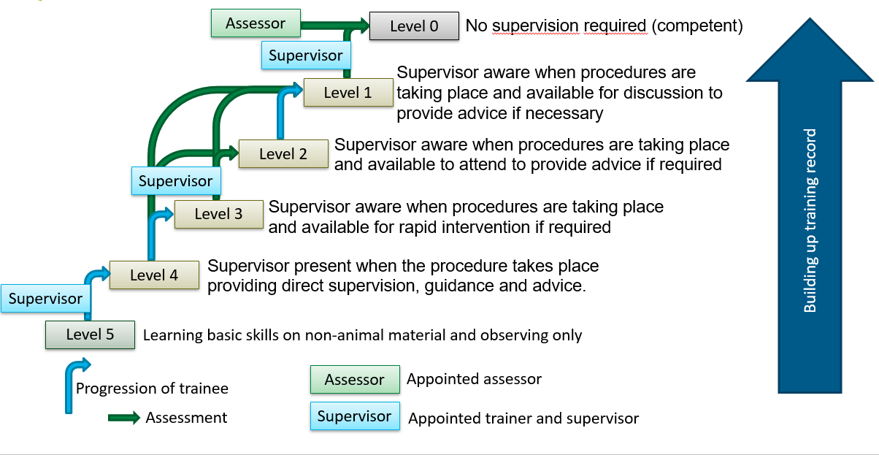

Appendix 2

Assessment Criteria

In general you need to be trained (and records of this training need to be kept) for each procedure, and your practical skills will be assessed before unsupervised execution of the procedure is allowed. The Assessment Criteria are summarized in the following ‘generic assessment checklist’. Guided by these points, a person’s competence is determined.

- Making proper preparations,
- Performing the procedures correctly,
- Understanding of the technique (theory behind it) and means used (including injection fluids).
- An eye for animal welfare (3 Rs), including aftercare, and acting accordingly,
- Ability to self-reflect on the manner of execution

Appendix 3

Basic procedures

handling
restraining
weighing
identification without anesthesia
tissue collection for genotyping
non-invasive measurements, e.g. ECG
SC, IP, oral gavage, intranasal, rectal administration
blood sampling via tail vein nicking, tail clipping, scab method, or cheek puncture
nose-, throat-, rectal-swabs
CO₂ euthanasia
vaginal plug monitoring with instruments
temperature recording
feeding and fasting
placing in metabolic cage
behavioral research

transferring animal to a set-up for observation
Complex procedures

Orbital blood sampling, cardiac puncture
Implantation of mini-pumps
radiation
hot/cold plate
injection into organs under anesthesia
complete anesthesia injection, induction and recovery
hysterectomy
vasectomy
castration
ovariectomy
nephrectomy
splenectomy
thoracotomy
craniotomy
adrenalectomy
orthopedic surgery
biliary cannulation
lung lavage
skin graft
implant under anesthesia
bone marrow aspiration

Less complex procedures
IV, foot sole, IM, intracutaneous administration
Isoflurane anesthesia, induction and recovery
lege artis decapitation
cervical dislocation
mild electric shocks
milking of rodents

