Seminar 12 February 2019
Translocation of particles to the fetus and consequences for biological ageing
Tim Nawrot  Hasselt University, Centre for Environmental Sciences (CMK) |  |  | 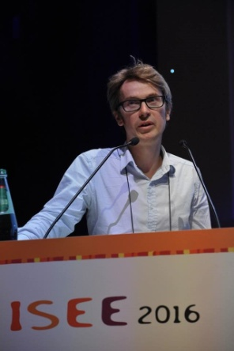
When & where  16.00-17.00 hrs  Mertens E, route 140  Host  Paul Scheepers  For registration visit:  - |  | Biography  Tim Nawrot studied Environmental Health Sciences at Maastricht University and Vermont Medical School (USA). In 2005 he obtained his PhD degree in medical sciences from the University of Leuven, Belgium and in 2008 he founded the molecular and environmental epidemiological research domain at the Center for Environmental Sciences, Hasselt University, where he was appointed professor of environmental and molecular epidemiology in 2016. In addition, he is part-time (20%) senior lecturer in environmental epidemiology at the University of Leuven. His research focus on health effects of environmental pollutants on ageing including effects in early life.  Tim Nawrot has published more than 200 scientific articles, including the Lancet and British Medical Journal and fulfilled advisory functions for the World Health Organization, the Dutch Health Council and the European Union (Vilnius Declaration). In 2012 he received from the European Research Council the prestigious ERC fund.  Tim Nawrot received two awards (in 2008 and 2012) from the Royal Belgian Academy of Medicine for his contribution to preventive medicine.

