The project “Buitengewoon Baanbrekend” (roughly translated as extraordinary groundbreaking) is an intraprofessional learning project between GP trainees and paedicatric trainees aimed at improving the care for the acutely ill child.
Buitengewoon Baanbrekend
In 2020 the pilot project Buitengewoon Baanbrekend started as a collaboration project between the paediatric department of the CWZ hospital and the GP practices and out of hours GP post in Nijmegen. Intraprofessional means learning between professions (in the primary and secondary care setting). GP trainees and paediatric trainees who were situated for their training in Nijmegen could participate in this project. Per 2022 the project expanded to the paediatric department of Rijnstate hospital and the GP post in Arnhem and we hope to expand further in the fall of 2022.

Aim of the project
The aim of our project Buitengewoon Baanbrekend is to train core trainees (GP and paediatric) intraprofessionally around the (acutely) ill child. Trainees will be trained together to work transmurally (through the walls of the hospital from primary and secondary care and back) so that the future doctors learn to practice integrated child care. Central in this project is that the learning is mutual. GP trainees will be able to improve their knowledge about paediatric care and improve their referrals skills and paediatric trainees will be trained to improve their consultation skills. Both parties will be better equipped with understanding eachothers working situation, improving future collaboration.
Project summary
In this project, GP and paediatric trainees see and examine sick children together in eachothers context and discuss their findings afterwards. The discussions afterwards are specifically focused on intraprofessional collaboration. What went well, what could go different, how does another setting changes your perspective on the child? Apart from these learning events, there is also a range of seminars (we call them hot topics) and several meetings to monitor the progress of the project.

For who?
Trainees who can participate are:
Paediatric trainees from CWZ and Rijnstate hospital
For paediatric trainees it is important that they are qualified to do shifts independently. The paediatric supervisor decides which trainee would be eligible for participation.
GP trainees (first year and third year) who applied and have been selected for the project.
Their GP supervisor and practice has to be connected to the out of hours GP post at either the CWZ or Rijnstate hospital. If the number of applicants exceeds the available spots for the project, third year trainees will be selected first.
How does it work?
AIOS duo’s
GP and paediatric trainees will be coupled up to form a trainee-duo. This duo will be partnered up for at least 6 months, so that they can plan exchanges to eachothers setting. The aim is for the trainees to examine children together both twice in their own setting as well as in the duo partners settings. A new group of trainees starts every March and September and a new group of trainees are able to partner up and start the project. During the project there will be 2-3 DUO meetings, where participants have a change to meet their partner for the first time, get to know eachother, get to know the goals for the project and also to monitor the progress of the project.
Examining children in eachothers context. How does that work?
The trainee duo’s will examine children in eachothers setting for at least 4 times. 2x in both their own training setting as well as the others. The dates for these exchanges can be planned by the duo’s themselves and need to be approved by their supervisors.
The program parts
1. A shift at the out of hours GP post
Out of all the patients attending the GP post, children will be pre-selected by the doctors assistant for the GP-paediatrician trainee-duo to see. Other GP’s working that day will be seeing the other ‘regular’ patients. This is a shift in GP setting, so when the duo is in doubt and needs supervision, the GP mentor is responsible for this.
2. A shift in the hospital (A&E department and paediatrics inpatient ward)
The GP trainee works along the paediatrics trainee for a (part of the) day. Supervision is provided by the paediatrician.
3. In the general practitioner practice
The paediatric trainee works alongside the GP trainee in the GP practice where the GP trainee is situated for the year. Preferably, the doctors assistant tries to plan the consultation hours with mostly children, but if this is not possible they see adult patients as well. The goal is to learn from eachothers setting and therefore, even seeing adult patients will provide a learning opportunity.
4. At the outpatient paediatrics ward
The GP trainee works alongside the paediatrics trainee at the outpatient ward.

5. Extra option: follow up of a referred child at the A&E department
For the GP trainee there is an option to follow a referred child as it is referred to the A&E department.

Conditions: For all program parts, it is required that the supervisor is on call or present at the location so that he/she available for consultation. When in doubt about diagnostics or policy, the supervisor of the hosting side is responsible for making the final decision.
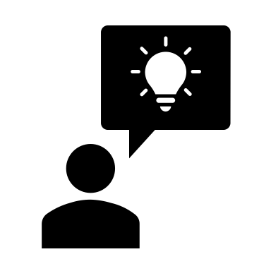
Talking through the learning experiences afterwards
To give meaning to the learning experiences with regards to their role as future GP’s and paediatricians, the duo’s are invited to discuss their learning experiences afterwards with the help of a ‘besprekingsformulier’ (i.e discussion form). This form will facilitate to explore how intraprofessional collaboration was used in seeing sick children. It stimulates to evaluate not only the medical points learned, but on the contrary, look closer to integrated care and take a closer look at both their role as consultant and referring specialist.

Education meetings
1. introduction meeting
This is a general introduction for all core trainees interested in a possible participation of the project.
2. DUO meetings (three times per 6 months)
Within a month after making up the pairs of GP-paediatrics trainees the first DUO meeting will be held as an informal meetup with eachother as well as with the project. A second DUO meeting will take place 3 moths after the start of the project, to monitor the progression of each duo pair and exchange experiences.
3. Case meetings
Twice a year a facultative meeting will be held for all GP and paediatric trainees, was well as their supervisors. In this meeting interesting cases will be discussed where integrated care played either a positive or less positive role and to bring about discussion between professions on the challenges regarding working intraprofessionally.
4. Hot topics
5 times a year we provide an online seminar for the GP trainees to gain more knowledge on common paediatric topics. Apart from the medical point of view, the question whether a child can stay under GP care or should be referred to the pediatrician is important in these meetings. These meetings are also open to GP trainees who don’t participate in the project.
Research
In the pilot fase of this project, a research was conducted to evaluate the effect on intraprofessional feedback, dialogue and reflection in regards to the collaboration around (acutely) ill children. The first fase of the study was finished and during the next fase of the project, where we are expanding to more locations, we will continue to actively monitor and evaluate the project.
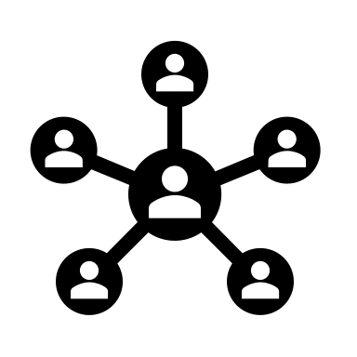
People involved
General practitioner training Radboudumc
Rosalin van Schie, GP/expertteacher childcare, PhD candidate Enhancing education in acute paediatric care for GP residents
Sharon Vrooijink, GP/juniorteacher childcare
Anne van Tuijl, educationalist
Bart Thoonen, program leader teaching primary care
Claudia Lobo, GP/ head of the department GP trainees Radboudumc
\
From UMC Groningen prof Nynke Scherpbier is involved
Paediatric training
Radboudumc:
Ester Coolen, paediatrician
Jeannette Bleeker, paediatric trainee
Canisius Wilhelmina ziekenhuis:
Paul Voorhoeve, paediatrician
Mirjam Binnenkamp, paediatric trainee
Rijnstate ziekenhuis:
Margreet Wessels, paediatrician
Marloes Rood, paediatric trainee
GP post Nijmegen
Eva ouwendijk, GP/manager GP post
Hans Padmos, teamleader
GP post Arnhem
Henk Meussen, GP
Inge Nuijten, GP
Jacqueline Berends, GP

