Personal Development Plan for postdocs

Your postdoctoral period is a time of growth towards your independent career. Your relationship with your supervisor is a key aspect of that growth; maintaining the clear, open communication is important. The aim of the PDP is to stimulate postdocs to be proactive in their own career development and to catalyse the communication with your supervisor. It is a document which helps you to identify your goals and objectives, both for your research and personal development. You and your supervisor will actively participate in this process. Essentially, the PDP will help you to:

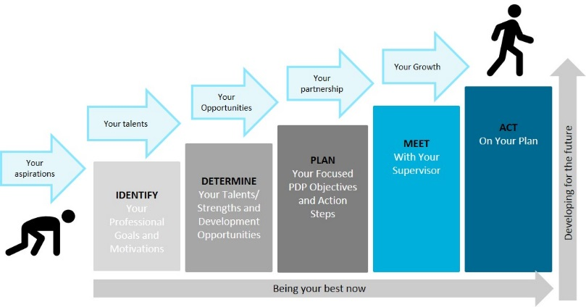
- Identify your strengths, talents, passions, and values, and planning ways to use them in your job
- Set goals to learn or improve competencies you will need now or in the future
- Identify and pursue your personal goals for your career development
- Facilitate the discussion with your supervisor

More information on Radboudumc PDP website

Personal information
Initials
First name
Prefix
Last name
Personnel number
Work email
Private email
LinkedIn
Gender
Land of birth
Mobile number
Date of PhD defence

Current contract
Starting date postdoc
End date postdoc
MD | Yes/no
Department
Research Theme | Choose one of the 18 Radboudumc Research Themes
Research Institute | RIMLS/RIHS/DCMN
Supervisor
Mentor | Do you wish to have a mentor? Yes/no.  If you have a mentor, please add name of the mentor
Finances | Kind of grant (supervisor’s/ personal); Funder
Fte (total) | Research | Education | Patient care | Other (please specify)

Date of PDP meeting

Self-assessment
Which of my past accomplishments will contribute to the success of this postdoctoral period? What skills am I bringing?

Research, Professional goals and motivations
What areas of learning I would like to develop? What are my professional growth and career aspirations? What professional skill I would like to develop/improve? How do I think these aspirations can be best met at Radboudumc?

Talents and strengths to use more (3-5)
What are my talents and strengths?

Development opportunities (1-2)

What skills or knowledge do I need to increase?

What is my ultimate career goal?
Academic Research position, Other, please specify

What career goal does my supervisor advise me?
Research position (at Radboudumc), (Research) position outside academia

PDP objectives and action steps
What development goals do I have for the next 12 months? And for the next 5 years?
What specific actions (courses, activities) can I take to achieve these goals?

Objective | Result | Development activities | Timeframe | Progress

Next review meeting date

Statement of agreement:

Name Postdoc: | Name Supervisor:
Date: | Date:
Signature: | Signature:

Please send this form to: Postbus Postdoc Office

