Policy on surplus and reuse of laboratory animals
Author: Animal Welfare Body
Last revision: October 15, 2019

Index

- INTRODUCTION
- SITUATIONS BY WHICH SURPLUS ANIMALS BECOME AVAILABLE
- REQUIREMENTS FOR USE/REUSE OF A SURPLUS ANIMAL
- RESPONSABILITIES
- ROUTE TO GUARANTEE PROPER USE/REUSE OF A SUSPLUS ANIMAL
- EUTHANASIA

- INTRODUCTION
Research facilities frequently have surplus animals. The use or reuse of these animals is encouraged whenever possible as an ethical principle of reduction of animals bred without fulfilling any scientific purpose. In this policy, we aim to instruct the users of laboratory animals on the expected actions regarding surplus animals and the requirements for reuse of animals at the Animal Research Facility (Centraal Dierenlaboratorium, CDL) of Radboud university medical center. This policy ensures compliance with Dutch legislation (Experiments on Animals Act, Wet op de dierproeven, Wod) regarding reuse of laboratory animals.

Surplus The term surplus is applied to a laboratory animal that instead of being killed could be used for other scientific purposes. These animals may have been used in experiments or breeding and they are no longer needed or suitable for their original purpose. In research and education, animals may become available because killing them immediately after an animal procedure is not always necessary.

Reuse The term reuse is applied to a laboratory animal that has been used for a scientific purpose (ex. experiment 1, or offspring with a likely harmful phenotype), and, after an evaluation of its health and general welfare status, that is allowed to be used for another scientific purpose (ex. experiment 2).

- SITUATIONS BY WHICH SURPLUS ANIMALS BECOME AVAILABLE
Animals used in an experiment In some cases it is possible to anticipate when and how many surplus animals will become available. During the evaluation of a work protocol, an AWB member meets with the researcher(s) and discusses the experimental plan. In the protocol, it must be clear when the animal experimental procedures will end. By then, it is possible for the AWB to make a first assessment of the possibility of a surplus availability. When it is certain that the immediate termination of an animal after the research procedures is not necessary to answer the original question of the work protocol, the AWB will advise the researcher to make the experimental animals available as surplus after completion of the study.
Animals used for breeding In the case of breeding, the animals are experimentally naïve (genotyping is not considered an experimental procedure). They can be derived from retired breeders, culled from a breeding colony or weaned without a clear scientific purpose. In breeding, the available offspring may not be suitable for use due to their genetic background or sex, or the number of available animals may exceed experimental needs. The parent animals in breeding programs also need to be replaced at times due to age or performance, or removed to decrease the breeding rate. In those cases, the breeding coordinator is the person with the best insight on surplus availability.
Animals shipped and not used Occasionally animals are ordered for an experiment and not used. It could be that more animals are delivered than ordered. Sometimes extra animals are ordered and not used if, for example, losses during the experiment are lower than expected. It may also be that laboratory equipment indispensable for the experiment broke down and could not be repaired in time.
Animals from an experiment that is discontinued Discontinuation of an experiment usually happens when the researcher has a clear indication that the data produced are no longer useful. In this case, an experimental animal may be made available as a surplus.

- REQUIREMENTS FOR USE/REUSE OF A SURPLUS ANIMAL
The fact that an animal is donated as surplus does not directly imply that it can or will be used/reused.
Legal requirements The history of the animals should be evaluated on a case-by-case basis to determine if the surplus animal can be used/reused. The use of laboratory animals for scientific purposes and education is regulated by the Directive 2010/63/EU and the Dutch legislation, Experiments on Animals Act. Experimentally naïve animals are here defined as animals not previously subjected to any experimental procedure. These animals can therefore be used for an experiment or educational purposes. Animals previously used in one or more procedures may only be reused if:
- the actual severity of the previous procedures was ‘mild’ or ‘moderate’;
- it is demonstrated that the animal’s general state of health and well-being has been fully restored;
- the future procedure is classified as ‘mild’, ‘moderate’ or ‘non-recovery’;
- reuse is in accordance with veterinary advice, considering the lifetime experience of the animal.
When is reuse not acceptable An animal may not be reused if health or welfare appear compromised. Reuse is also not acceptable if live-transfer to another research facility is required, because of risks associated with possible differences in microbiological status and stress related to transportation.

- RESPONSABILITIES
Animal Welfare Body (AWB) assesses if the reuse of a surplus animal is in accordance with the Dutch legislation and stimulates the reduction of the number of animals used.
Attending veterinarian advises on matters related to the health and general welfare of animals that are donated as surplus.
Breeding coordinator oversees the breeding program and communicates with the AWB and researchers on matters related to optimal breeding size and surplus availability.
Owner of the animal enables reuse by communicating with the AWB when a surplus animal becomes available. The animal’s owner may be the researcher or a representative of the animal research facility.

- ROUTE TO GUARANTEE PROPER USE/REUSE OF A SURPLUS ANIMAL
There is a sequence of actions that should be followed to guarantee that the use of surplus animals is optimized and communication between all the parties involved is clear and effective. First, the owner of the animal should differentiate between animals that have been subjected to an experimental procedure and animals that have not. If the animal has not undergone any experimental procedure, no extra welfare assessment from the AWB or attending veterinarian is required (so-called naïve animal). When an animal has previously been used for an experimental procedure (genotyping does not count as a procedure), then the animal can be donated as surplus. In this case (so-called not naïve animal), reuse is allowed only after the approval of the AWB and/or the attending veterinarian of CDL. Please bear in mind that when the person is only interested in post-mortem collection of animal material (ex. blood, organs, tissues) from one or a few animals for in vitro testing, the direct use of a surplus without the AWB approval is possible and a project license is not necessary. These animals, in this case, can only be euthanized using standard methods, cervical dislocation or carbon dioxide. A full description of the process and the key communication between all those involved in the use or reuse of a surplus is presented in Figure 1.

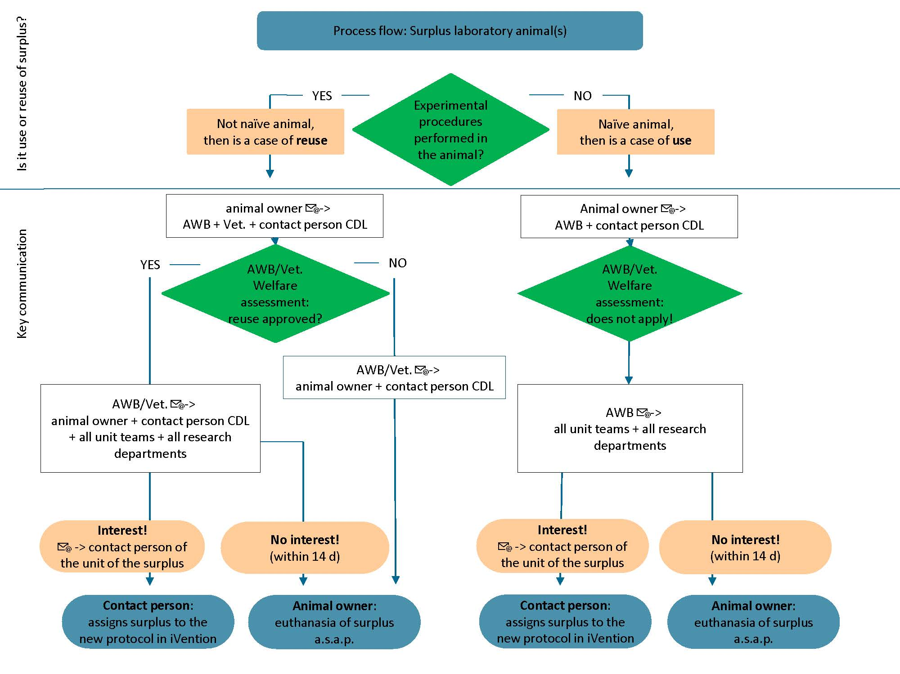
Figure 1. Process flow of use or reuse of surplus laboratory animal(s) at CDL.

Procedure and communication when naïve animals are donated as surplus
In the case of a naïve animal, the direct use of the animal without a welfare assessment by the AWB or attending veterinarian is possible. For that, the owner of the animal should notify, per e-mail, the availability of the surplus to the AWB (instantievoordierenwelzijn@radboudumc.nl) and to the contact person at the CDL unit where the surplus is housed. The AWB will forward the e-mail to all animal units and the animal experiment coordinators of the research departments. If somebody in their unit or department is interested in using the surplus, he/she should e-mail the contact person at the CDL. Then the surplus will be assigned to the new protocol in iVention. If nobody shows interest within 14 days, the surplus must be euthanized as soon as possible.

Procedure and communication when not naïve animals are donated as surplus
Step 1: The owner of the animal sends a notification to the AWB, attending veterinarian and CDL contact person.
The owner of the animal, or a representative (the responsible researcher or the breeding coordinator), should notify the AWB by e-mail (instantievoordierenwelzijn@radboudumc.nl), the attending veterinarian (Manon.vanHulzen@radboudumc.nl ) and the CDL contact person (of the unit where the animal is housed) when a surplus animal will become available. The aim should be to do this as soon as possible, as this will increase the chance of quickly finding a suitable use for the surplus animal. This e-mail should provide information such as the species, number of animals, sex, age, genetic background, work protocol number, short summary of procedures performed on the animal, registered level of discomfort and date of availability.
Step 2: Assessment of the health and welfare of the animal
The AWB and/or the attending veterinarian will assess whether the surplus animal is suitable for reuse for scientific/educational purposes within five working days.
Step 3: The AWB sends a notification to the CDL team coordinators and the animal experiment coordinators of the research departments
If during the assessment the animal is considered suitable for further use, the AWB will inform the CDL team coordinators and animal experiment coordinators of the research departments by e-mail about the availability of the surplus animals. The e-mail should provide relevant information about the surplus animal and its history. The animal experiment coordinators should forward this e-mail to the researchers working in their units.
If the animal is not considered suitable for further use, the AWB will communicate to the animal owner and CDL contact person that the animal should be euthanized as soon as possible.
Step 4: Communicate interest
Researchers or animal technicians involved in training can express their interest in reuse of a surplus laboratory animal if they have a project license where the surplus can be registered. The researcher should clearly discuss with the team coordinator who will collect the samples. Exception: if the person is only interested in post-mortem animal material, then a project license in not necessary. The CDL staff may be able to collect the samples for the researcher, but he will be charged a fee.
The person’s interest in the surplus should be communicated by e-mail to the contact person of the unit where the surplus is located. The e-mail should indicate the expected level of discomfort (maximum moderate) that will be inflicted and the protocol number to which the animals will be assigned.
Step 5: Conditions to make the transfer possible
The CDL contact person should clarify the terms and conditions for making the transfer possible, such as arrangements in temporary housing, expenses, and responsibilities. All expenses related to the temporary housing will be charged to the researcher who demonstrated interest in the animal. Possible payment for the animals will be arranged in consultation between a CDL team coordinator, the old and new owner of the animal.
Step 6: Protocol-to-protocol transfer of animals
To ensure proper tracking of documentation, the surplus animal(s) will be transferred to the protocol of the person with the approved request from the AWB. Until the time of use, which should not last longer than 14 days, the animal will be under the temporary housing conditions. If the researcher does not use the animal, it will be euthanized and the researcher /project will still be charged with costs related to the surplus (housing, euthanasia).
- EUTHANASIA
Even with a surplus use/reuse policy in place, not all surplus animals may be used or reused. The AWB will mandate that the animal is humanely killed according to the EU Directive 2010/63/EU, when:
- the animals are evaluated and found unsuitable for reuse
- there is no interest in the surplus animal within 14 days
- it is clear for the AWB and attending veterinarian that there will be no interest in the animals

List of documents consulted in the preparation of this internal policy

European Directive 2010/63/EU of the European Parliament and the Consul on the protection of animals used for scientific purposes.
Experiments on Animals Act, Wod. 2014.
Policy on surplus laboratory animals, reuse and rehoming. Animal Welfare Body of Utrecht University.

